FatBurner - new app for calculating ground truth in calories burned while running



### PREPARED FOR

Sungahn Ko

Professor, School of Computer Science and Engineering, Unist

### PREPARED BY

Alisheri Anvar

Nodirbek Parpibaev

Muhammadjon Boboev

[FatBurner - a new app that calculates the ground truth in calories burned while running]

Dec 21, 2020

### 

### Team NuPogodi

**Motivation**

At this time in history, exercising particularly running has become an irreversible habit for millions all around the world. People jog for many reasons like for burning fat, getting fit, healthy or just out of love for jogging. Irrespective of the reason why people run regularly, most of them use smartphone apps to track their movements, to get a guide or to calculate related figures like speed, distance and the amount of calories burned so that they can keep up, control and improve their performance. It is important and practical to know exact amounts for these figures but getting ground truth for them is complicated and requires a lot of parameters like weight, gender, age, heart rate, slope of the road, wind speed, the condition of the road and so on, some of which are hard to extract. Most wearable devices and only a few smartphones have sensors like a heart rate calculator, which is a major parameter to calculate the calories burned in particular but what about the smartphones that don't have such sensors? There are some simple formulas and apps that can calculate the ground truth for finding calories burned running, which utilize weight and the speed of the user. However, they give very raw estimates and they don’t take account of the slope of the road, which has a major effect in evaluating the amount of calories burned while running. In this project, we proposed an app that computes the burned calories while running, taking into account the slope of the road spontaneously.

**Related Work**

There are some works and papers related to this area: 2 papers in particular (1). They gave solutions to the same problem but their methods included machine learning and deep learning models. But to implement them, one needs a tremendous amount of data. Not only that the data must be very accurate. It must include different ages, weights, genders, slopes with the exact amount of calories burned by each group and individual as labels.

There is also another paper not related to computer science but to estimating Energy loss (2). This paper gives very good estimates to calculate the energy loss taking into account the speed of the user and the slope of the road. Based on the work in this paper we derived several formulas to calculate the calories burned for several slope figures.

**System architecture**

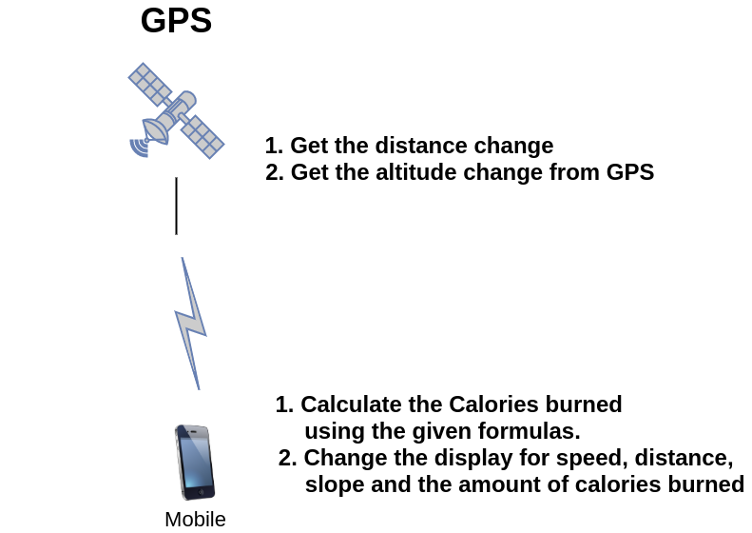

**Implementation**

The app calculates the distance and altitude difference in a small time interval. Then it calculates the speed from the distance difference in that time interval and the slope of the road from altitude change. The calculations are fed to one of these kinds of formulas:

**For 0% grade: CB = [0.0215 x KPH^3 - 0.1765 x KPH^2 + 0.8710 x KPH + 1.4577] x WKG x T**

here:

CB = Calorie burn (in calories)

KPH = Walking speed (in kilometres per hour)

WKG = Weight (in kilograms)

T = Time (in hours)

(The parameters in front of the arguments are different for different slopes. Also the 0% grade means slope of 0, flat surface. Here the slope unit is a little bit different. It is in percents. 5 % grade slope means: 20 units forward and 1 unit up ⇒ 1/20 = 5% )

The calories burned in that time interval is calculated and added to the overall figure. Finally all the entries in the front display of the app are renewed. Overall, we implemented a chronometer for time, GPS for distance, altitude, UI for display and the actual burned calories calculator input from received data.

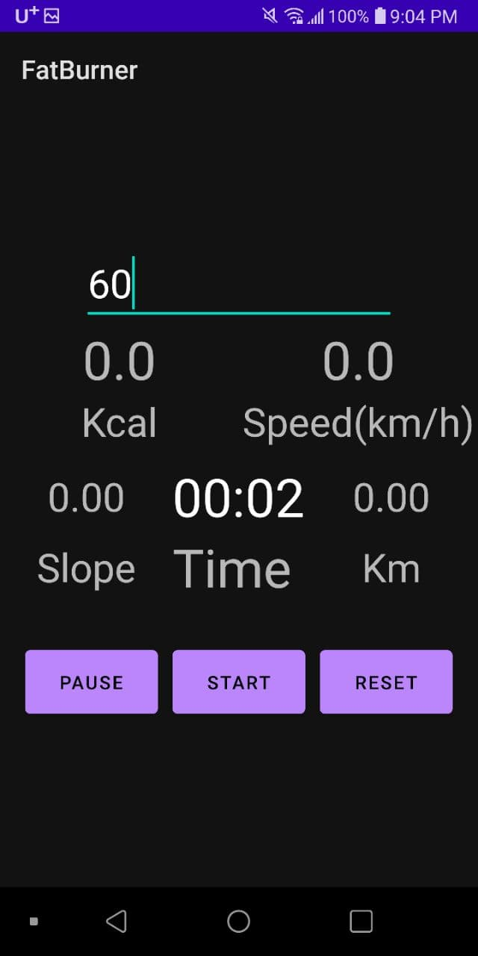

**Evaluation**

**DATA Collected**

***Person: 70kg, 190cm***

**1. 700meters straight path**

Our APP: 50cal 5.5Km/h Slope = 0m

Nike Run: 39cal 5.56km/h

Adidas Run: 50cal 5.8km/h Slope = 10m up, 8m down

Relive: 5.5km/h Slope = 20m

**2. 300meters uphill (57m high, 19%)**

Our APP: 19cal 4.27Km/h Slope = 21%

Nike Run: 14cal 4.03km/h

Adidas Run: 40cal 4.1km/h Slope = 61m = 20.3%

Relive: 4.0km/h Slope = 78m = 26%

**3. 300meters downhill (-45m high, -15%)**

Our APP: 19cal 7.4Km/h Slope = -16%

Nike Run: 15cal 5.9km/h

Adidas Run: 28cal 10.6km/h Slope = -51m = -17%

Relive: 5.1km/h Slope = -80m = -26%

It is really hard to evaluate when one doesn't have enough accurate data as in our case. As the condition of the road to evaluate is irregular and also because of other factors like weather, wind and so on, we better compared our app with 2 of the best apps out there for running: the Nike and Adidas running apps. There is no clear trend in the data to follow but our app seems not to perform much differently than the other two.

**Contribution**

As it was a very important project, all of our team gathered and brainstormed in every aspect of this project. Some people were good at specific tasks but everyone is involved in every step to get the advantage of group work.

**References**

1. A. Pande, J. Zhu, A. K. Das, Y. Zeng, P. Mohapatra and J. J. Han, "Using Smartphone Sensors for Improving Energy Expenditure Estimation," in IEEE Journal of Translational Engineering in Health and Medicine, vol. 3, pp. 1-12, 2015, Art no. 2700212, doi: 10.1109/JTEHM.2015.2480082.

B. Aguiar, J. Silva, T. Rocha, S. Carneiro and I. Sousa, "Monitoring physical activity and energy expenditure with smartphones," IEEE-EMBS International Conference on Biomedical and Health Informatics (BHI), Valencia, 2014, pp. 664-667, doi: 10.1109/BHI.2014.6864451.

1. Beneke R. , Leithäuser R., “Energy Cost of Running Related to Running Intensity and Peak Oxygen Uptake”